Practical R Activity Three

Selecting Visualizations

Michael Surdek
Southern New Hampshire University
DAT 640: Predictive Analytics
Professor Tom Woolman
January 23, 2022
Prior to the modelling phase of the CRISP-DM process, the data miner should explore their data set so that they can begin to understand the stories that it may tell. Throughout this process, “insights gained can deliver new discoveries to our clients.” (Williams, 2011) Exploring the data can be as simple as determining the dimensions of the data set and the types of variables, or one can dive deeper into the characteristics of each variable. Some important characteristics to look out for include missing values, mean and median, skewness, and kurtosis. R and Rattle can be helpful for understanding the data by generating summaries and plots for exploring the distributions of the variables.
Quakes, one of R’s default data sets, contains 1000 observations of earthquakes in Fiji and information about each one’s location and severity through the 5 variables ‘lat’, ‘long’, ‘depth’, ‘mag’, and ‘stations’. The basicStats function from the fBasics package provides the following information about the quakes data set.
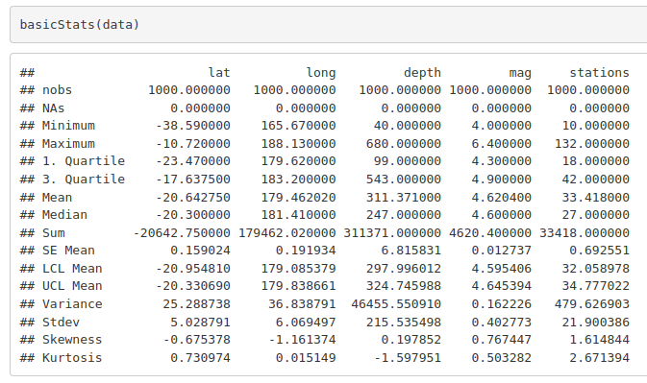
The output shows that there are 1000 observations for each variable and 0 NA values across the board. It also shows the minimum, maximum, mean, and other key values. The last two rows, skewness and kurtosis provide important details about the distribution of the variables, without having to look at a visualization of the data. Skewness “is a measure of how asymmetrically our data is distributed.” (Williams, 2011) A skewness value with a magnitude greater than 1 indicates that the data has a fat tail in one direction. The sign, positive or negative, of the skewness value shows whether the tail can be found on the right or the left. For example, the stations variable has a skewness of 1.6, and the chart below shows that the distrbution of the stations values has a fat right tail. This also makes sense based on the fact that the mean of the stations variable is 33.4 and the median is 27. Extreme values impact the mean, but not the median, so it is clear that the distrbution is skewed to the right.
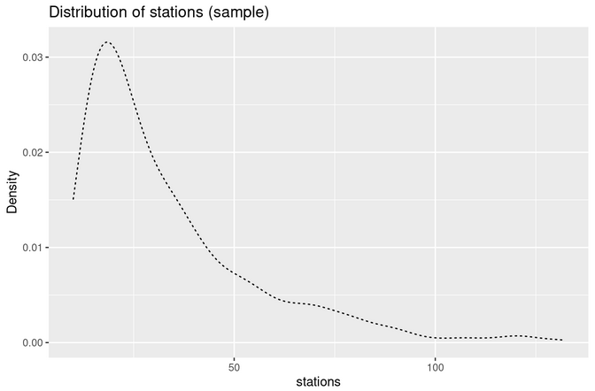

Kurtosis “is a measure of the nature of the peaks in the distribution of the data.” (Williams, 2011) A higher kurtosis value, such as the 2.7 for stations, indicates that there is a single sharp peak in the distribution, which can be seen in the chart above. On the other hand, a lower kurtosis value, such as the -1.6 for the depth variable, would indicate that there is no sharp peak in the distribution. This can be seen clearly in the depth distribution chart below. In fact, the depth variable is distributed bimodially, meaning that there are two separate values that are most common, with fewer observations falling below, above, and in between those values.
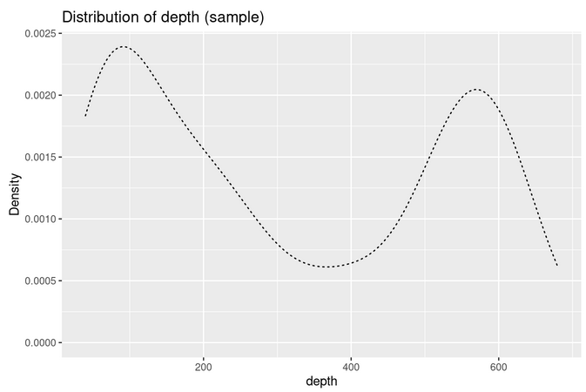

Developing and interpreting visualizations of data can be the start of uncovering the stories that the data tell. The charts above reveal information about the nature of individual variables, but visualizations can often paint the best picture when they reveal the relationships between variables. For example, the lat and long variables are essentially pairs that together provide the precise location of the earthquake. The chart below shows the latitude and longitude pairs in a scatterplot. There are clearly locations in Fiji that experience earthquakes more frequently. The visualization may even reveal borders between tectonic plates in the earth’s crust, which can be part of the story behind the data. Additionally, there is advanced mapping functionality in R, and it would be possible to overlay the scatterplot with an actual map of Fiji. A chart like that would show the exact locations in Fiji that are most impacted by earthquakes. People in those regions or cities may be more interested in the stories that the dat has to tell.
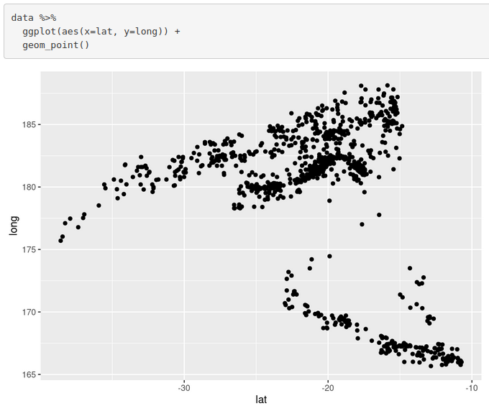
References:

Williams, Graham. 2011. Data Mining with Rattle and R : The Art of Excavating Data for Knowledge Discovery. Springer New York. Retrieved from http://ebookcentral.proquest.com/lib/snhu- ebooks/detail.action?docID=770229.

